Case study on cafe

INTRODUCTION

* + - Database design for cafe is to help automatic the process the sales,billing, and to make the transaction fast with accuracy, to secure data and to easily manage or manipulate the accounts of cafe. The database of the system will store all the information of product, employees, customer ,order payments etc.

ER DIAGRAM

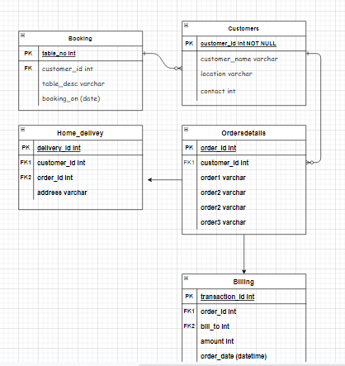

DESC TABLES:

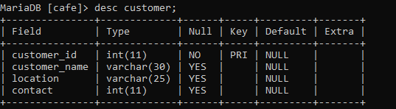

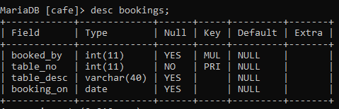

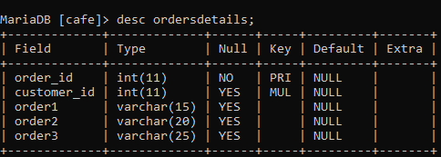

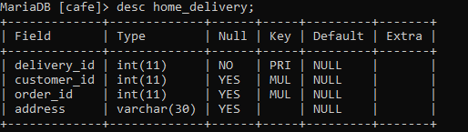

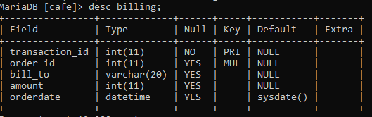

CONTENT OF TABLES

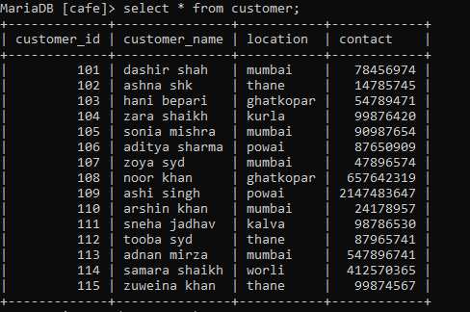

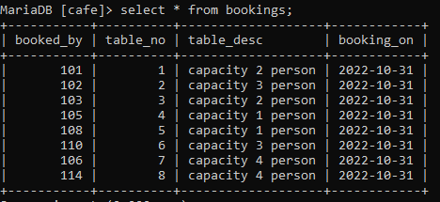

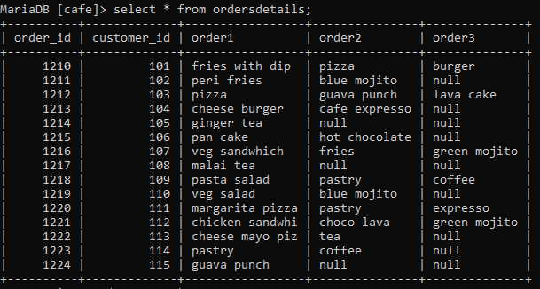

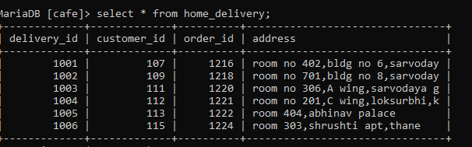

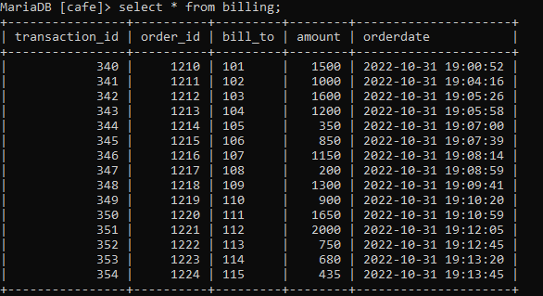

SUBQUERY:

(1). Find customer details having home delivery for.

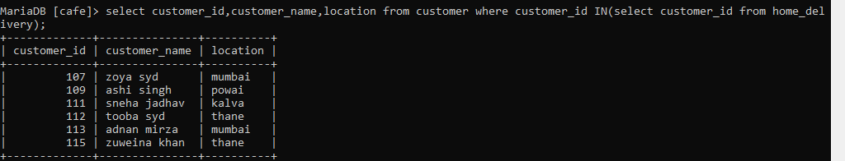

(2). Find customer details whose location is not Mumbai.

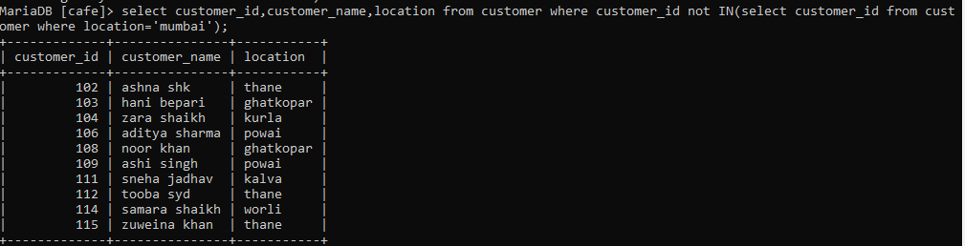

(3).Find customer whose order3 is null from ordersdetails.

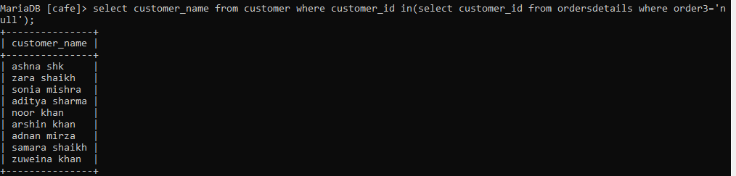

(4).Show data from billing where amount is greater than 1500.

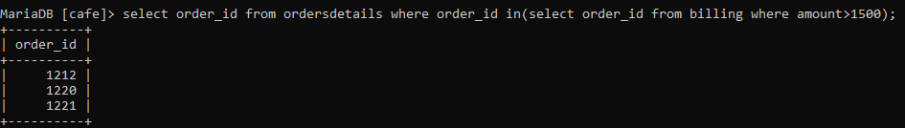

(5) Find orders from billing where amount is greater than minimum amount.

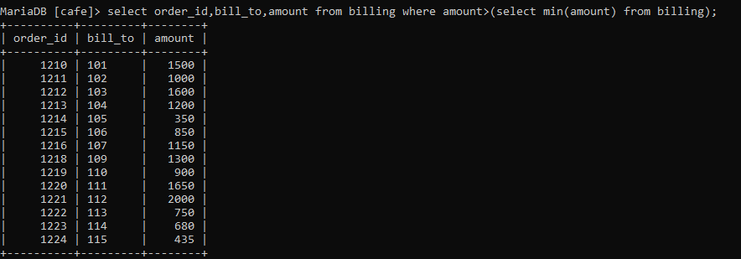

JOINS:

1. Join customer information with table booking.

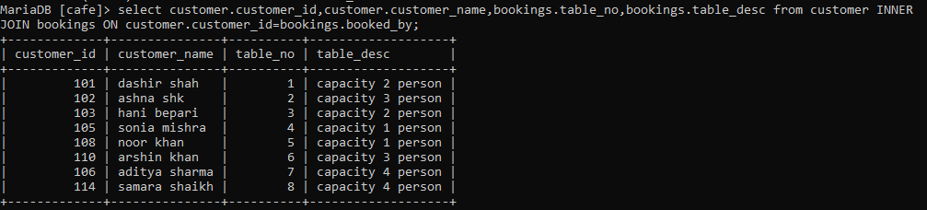

(2) Show customer who have home delivery orders

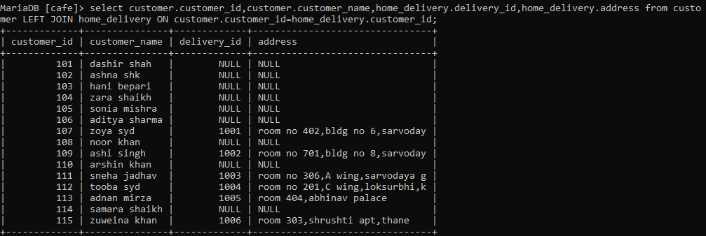

(3). Show orders of all customers

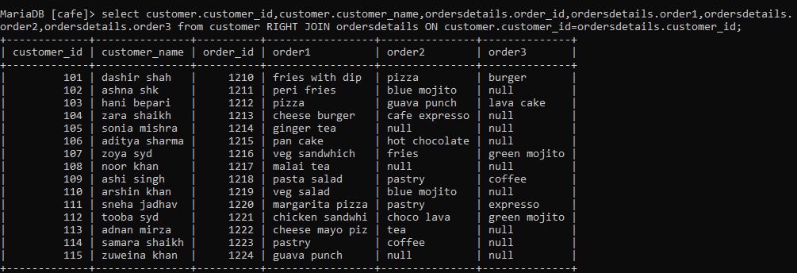

(4)Show orders details of home delivery

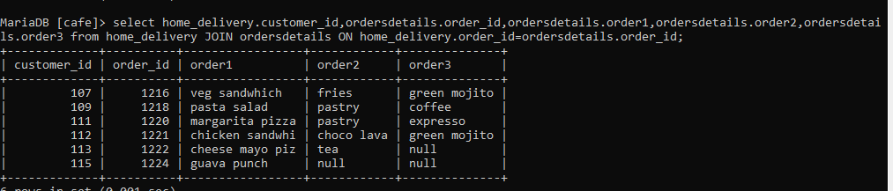

VIEWS:



